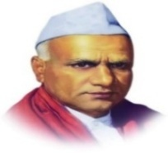
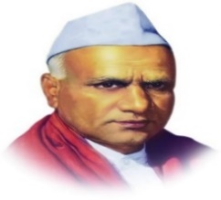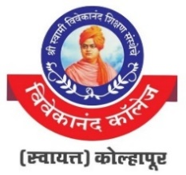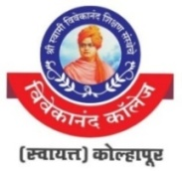

“Dissemination of Education for Knowledge, Science and Culture”

-Shikshanmaharshi Dr. Bapuji Salunkhe
Shri Swami Vivekanand Shikshan Sanstha’s
Vivekanand College, Kolhapur (Autonomous)
National Cadet Corps
(5 MAH BN NCC KOP)

NAME | JITENDRA RAVASO BHARAMGONDA
RANK | LIEUTENT
COMMISSIONED DATE | 13 DECEMBER 2015
GRADE | A
SERVICE DURATION | ∙14 MAY 2014 TO 12 SEPTEMBER 2015 CARE TAKER AT MIRAJ , DIST SANGLI .  ∙13 SEPTEMBER 2015 TO 28 FEBRUARY 2019 AS ALIEUTENT AT MIRAJ DIST SANGLI .  ∙01 MARCH 2019 ONWARDS AT VIVEKANANADCOLLEGE KOLHAPUR.
AWARDS | BEST ASSOCIATE NCC OFFICER OF KOLHAPUR GROUP 2019
CAMP | COMBINE ANNUALTRAINNING CAMP / TSC ASHTA , SANGLI 15 JULY 2014 TO 24 JULY 2014
 | COMBINE ANNUALTRAINNING CAMP / TSC KOLHAPUR , 15 JULY 2016 TO 24 JULY 2016
 | COMBINE ANNUALTRAINNING CAMP / TSC KOLHAPUR 15 JULY 2017 TO 24 JULY 2017
 | SHIVAJI TRAILYREEK CAMP BUDDHAWADI VISHALGAD KO;HAPUR 05 DECEMBER 2017 TO 14 DECEMBER 2017
 | SHIVAJI TRAILYREEK CAMP BAMBAWADE KOLHAPUR 26 NOVEMBER 2018 TO 04 DECEMBER 2018
 | COMBINE ANNUALTRAINNING CAMP/TSC KOLHAPUR 16 JULY 2019 TO 25 JULY 2019
 | SHIVAJI TRAILYREEK CAMP KOLHAPUR 26 NOVEMBER 2019 TO 04 DECEMBER 2019
 | COMBINE ANNUALTRAINNING CAMP/TSC KOLHAPUR 27 SEPTEMBER 2021 TO 06 OCTOBER 2021
 | COMBINE ANNUALTRAINNING CAMP / TSC KOLHAPUR 15 JULY 2022 TO 24 JULY 2022
 | SHIVAJI TRAILYREEK CAMP KOLHAPUR 26 NOVEMBER 2022 TO 04 DECEMBER 2022
 | COMBINE ANNUALTRAINNING CAMP / TSC KOLHAPUR 15 JULY 2023 TO 24 JULY 2023
NUMBER OF PLACEMENTS DURING TENURE | MIRAJ | VIVEKANAND COLLEGE KOLHAPUR
 | INDIAN ARMY 30  PSI 01 | INDIAN ARMY OFFICER  INDIAN NAVY OFFICERS  INDIAN ARMY SOLDIERS  INDIAN NAVY SOLDIER  INDIAN AIR FORCE SOLDIER  MERCHANT NAVY OFFICER | 01  01  06  03  01  01

