**“Dissemination of Education for Knowledge, Science and Culture”**

* **Shikshanmaharshi Dr. Bapuji Salunkhe**

**Shri Swami Vivekanand Shikshan Sanstha’s**

**Vivekanand College, Kolhapur**

**(An Empowered Autonomous Institute)**

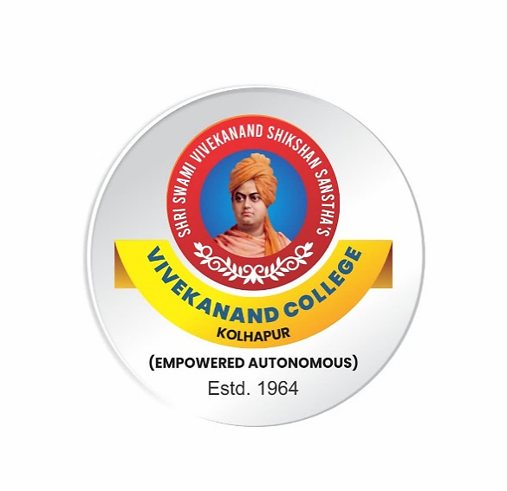

**Syllabus**

**for**

**Bachelor of Arts**

***B.A. Part-II***

**Minor**

**Functional English**

***(Semester III, IV)***

***Under NEP 1.0***

**Syllabus with effect from June, 2025**

(Subject to modifications in the future)

**To be implemented from 2025-2026**

**Paper- Minor I: Functional English**

**Semester III**

**Course Outcomes:**

**On completion of the course, students will be able to:**

CO1**:** Demonstrate professional communication skills in service-oriented and formal workplace settings, including telephone conversations and customer interactions.

CO2: Draft functional business correspondence such as letters of inquiry, replies, complaints, and orders with correct format, tone, and grammar.

CO3: Understand and apply grammatical structures, including clause types and modal/auxiliary verbs, in workplace communication.

CO4: Use English related to specific jobs like tourism, aviation, law, and hospitality in real-life situations to become better prepared for work in service industries.

|  |  |  |  |
| --- | --- | --- | --- |
| **Module No** | **Units** | **Teaching Hour** | **Credits** |
| **Module I** | Conversational English for Service and Professional Settings  - Introduction to Telephone Etiquette  -Structure of a Professional Call  -Handling Inquiries and Complaints | 15 | 1 |
| **Module II** | Business and Functional Writing  Letter of Inquiry, Reply to Inquiry, Letter of Complaint, Reply to complaint letter, Letter of Order | 15 | 1 |
| **Module III** | Grammar   * Structure and elements of clauses * Use of modals and auxiliary verbs in professional contexts | 15 | 1 |
| **Module IV** | Vocabulary   * One –word substitutes (subject-specific * Trade and profession-specific terminology (e.g., tourism, aviation, law, business, Hotel Management and Hospitality ) | 15 | 1 |

**Division of Teaching: 4 Modules X 15 Periods = 60 Periods Evaluation**

|  |  |  |  |
| --- | --- | --- | --- |
| **Semester** | **Theory/**  **semester-end exam** | **Practical/Internal Evaluation** | **Credits** |
| III and IV | 40 marks | 10 marks | 4 |

**Pattern of Question Paper for Theory Exam (Semester III)**

|  |  |  |  |
| --- | --- | --- | --- |
| **Q.No** | **Types of Question** | **Modules** | **Marks** |
| Q.1 | Telephone etiquette, professional calls, inquiries, and complaints | I | 10 |
| Q.2 | Letters: inquiry, reply, complaint, order | II | 10 |
| Q.3 | Clauses, modals, and auxiliary verbs | III | 10 |
| Q.4 | One-word substitutes, trade-specific terms | IV | 10 |

**Semester IV**

**Paper- Minor II: Functional English**

**Course Outcomes:**

**On completion of the course, students will be able to:**

CO1: Understand and use common English terms and expressions used in the tourism industry.

CO2: Write clear and concise summaries using effective techniques

CO3: Write grammatically correct and coherent sentences for everyday and professional communication.

CO4: Express compliments and handle complaints using appropriate and polite vocabulary.

|  |  |  |  |
| --- | --- | --- | --- |
| **Module No** | **Units** | **Teaching Hour** | **Credits** |
| **Module V** | English for Tourism  -Introduction to Tourism English  -Describing Places and Planning Itineraries  -Handling Inquiries and Complaints | 15 | 1 |
| **Module VI** | Comprehension and Summarizing  -Reading Comprehension  Summarizing :  - Techniques for summarizing and summary writing | 15 | 1 |
| **Module VII** | Subject–Verb Agreement  Effective use of Prepositions, conjunctions | 15 | 1 |
| **Module VIII** | vocabulary and expressions for specific purposes  - Ordering food and drinks  - Making comparisons  - Complaints and compliments | 15 | 1 |

**Division of Teaching: 4 Modules X 15 Periods = 60 Periods Evaluation**

**Pattern of Question Paper for Theory Exam (Semester IV)**

|  |  |  |  |
| --- | --- | --- | --- |
| **Q .No.** | **Types of Question** | **Modules** | **Marks** |
| Q 1. | English for Tourism | I | 10 |
| Q.2 | Comprehension and Summarizing | II | 10 |
| Q.3 | Grammar | III | 10 |
| Q .4 | Vocabulary and Functional Expressions | IV | 10 |

**References**:

1)Strutt, Peter. English for International Tourism. Pearson Education, 2013.

2)Walker, Robin, and Keith Harding. Tourism 1. Oxford University Press, 2006.

3)Grellet, Francoise. Developing Reading Skills: A Practical Guide to Reading Comprehension Exercises. Cambridge University Press, 1996.

4)Boardman, Cynthia A., and Jia Frydenberg. Writing to Communicate 2: Paragraphs and Essays. Pearson Longman, 2008.

5)Murphy, Raymond. English Grammar in Use. 5th ed., Cambridge University Press, 2019.

6)Swan, Michael. Practical English Usage. 4th ed., Oxford University Press, 2016.

7) McCarthy, Michael, and Felicity O'Dell. English Vocabulary in Use: Upper-Intermediate. Cambridge University Press, 2017.Gairns, Ruth, and Stuart Redman. Working with Words: A Guide to Teaching and Learning Vocabulary. Cambridge University Press, 1986.