**“Dissemination of Education for Knowledge, Science and Culture”**

* **Shikshanmaharshi Dr. Bapuji Salunkhe**

**Shri Swami Vivekanand Shikshan Sanstha’s**

**Vivekanand College, Kolhapur**

**(Empowered Autonomous)**

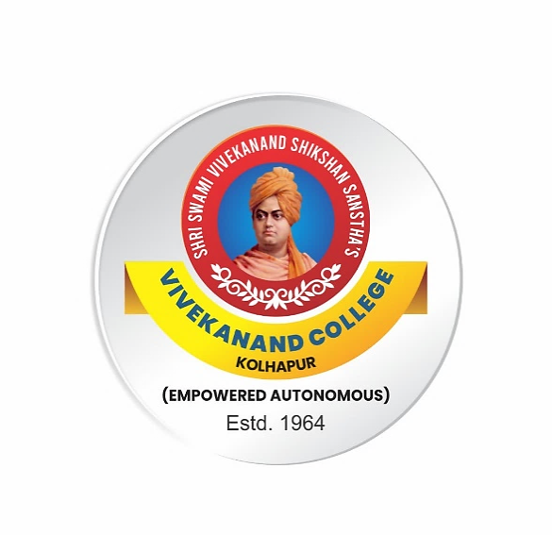

**Syllabus**

**for**

**B.Sc. Part II and B.Sc. (Biotech Entire) Part II**

**AEC: English for Communication**

***Under NEP 2020***

**Syllabus with effect from June, 2024**

(Subject to modifications in the future)

**To be implemented from 2024-2025**

**B.Sc. Part II and B.Sc. (Biotech Entire) Part II**

**AEC: English for Communication**

**Credits: 2 Theory: 40 marks Internal: 10 marks**

**Semester III**

**Course Outcomes:**

**After completion of the course the students will be able to:**

CO1: Develop communication skills in English, both oral and written

CO2: Refine understanding through discussion and explanation.

CO3: Acquire language skills for employability.

CO4: Inculcate human values through poems and prose.

|  |  |  |  |  |
| --- | --- | --- | --- | --- |
| **Module** | **Skills** | **Sub-points** | **Teaching**  **hours** | **Credits** |
| **Module I** | **Oral Skills** | * **Oral Skill** * **Group Discussion** | 15 | 1 |
| **Module II** | **Prose** | * Youth and the Tasks Ahead by Karan Singh * The Ant and the Grasshopper by William Somrest Maugham * Kusum by Khushwant Singh |
| **Module III** | **Poem** | * To Science by Edger Allan Poe * Evolution by Sharman Alexie * Father Returning Home by Dilip Chitre |

**Pattern of Question Paper**

**Marks: 40 Time: 40 marks**

|  |  |  |  |  |
| --- | --- | --- | --- | --- |
| **Que. No** | **Sub. Q.** | **Types of Question** | **Based on** | **Marks** |
| Q.1 | A | Four **multiple choice questions** with four alternatives. | Module II & III  (Prose & Poem) | 04 |
| Q.2 | A | Answer the questions in 3 to 4sentences (3 out of 5) | Module II & III  (Prose & Poem) | 06 |
|  | B | Write short notes (2 out of 4) | Module II & III  (Prose & Poem) | 10 |
| Q.3 |  | Questions to be set on Oral Skill(2out of 3) | Module I | 10 |
| Q.4 |  | Questions to be set on Group Discussion (2 out of 3) | Module I | 10 |

**Continuous Internal Evaluation**

|  |  |
| --- | --- |
| **Evaluation Type** | **Marks** |
| Home Assignment/ Open Book Test/ Tutorial/Unit Test/ book review/ student project | **10** |

**B.Sc. Part II and B.Sc. (Biotech Entire) Part II**

**AEC: English for Communication**

**Semester IV**

**Course Outcomes:**

**After completion of the course the students will be able to:**

CO1: Study different styles of note-taking and note making

CO2: Improve their memory and study more efficiently

CO3: Prepare for various competitive exams by developing their English language competence.

CO4: Inculcate human values through poems and prose.

|  |  |  |  |  |
| --- | --- | --- | --- | --- |
| **Module** | **Skills** | **Sub-points** | **Teaching**  **hours** | **Credits** |
| **Module IV** | **Written Skills** | * Note Making and Note Taking * Writing for Competitive Exams | 15 | 1 |
| **Module V** | **Prose** | * Karma by Khushwant Singh * The Tiger in the Tunnel by Ruskin Bond * The Prophet who taught India how to win by Shashi Tharoor |
| **Module VI** | **Poem** | * Enterprise by Nissim Ezekeil * The Granny by Tejswini Patil * The Butterfly by Arun Kolatkar | 15 | 1 |
|  |  |  |

**Pattern of Question Paper**

**Marks: 40 Time: 40 marks**

|  |  |  |  |  |
| --- | --- | --- | --- | --- |
| **Que. No** | **Sub. Q.** | **Types of Question** | **Based on** | **Marks** |
| Q.1 | A | Four **multiple choice questions** with four  alternatives. | Module V & VI  (Prose & Poem) | 04 |
| Q.2 | A | Answer the questions in 3 to 4sentences (3 out of 5) | Module V & VI  (Prose & Poem) | 06 |
|  | B | Write short notes (2 out of 4) | Module V& VI  (Prose & Poem) | 10 |
| Q. 3 |  | Questions to be set on Note Making and Note Taking (2 out of 3) | Module IV | 10 |
| Q. 4 |  | Questions to be set on Interview Skills(2 out of 3) | Module IV | 10 |

|  |  |
| --- | --- |
| **Evaluation Type** | **Marks** |
| **Home Assignment/ Open Book Test/ Tutorial/Unit Test**  /book review/ student project | 10 |

**References:**

horat, R., Valke, B. S., and Gokhale, S. B. *Enriching Your Competence*. Orient Blackswan, 2000.

*Oasis*. Board of Editors. Orient Blackswan, 2022.

*Literary Quest*. Board of Editors. Orient Blackswan, 2018.

*English for Communication: B.Sc. III Text*. Shivaji University, Kolhapur, 2015.

*Pathmaker*. Board of Editors. Orient Blackswan, 2021.

Coleman, Kelth. *Effective Communication Skills*. ASIN: B071J5S2F9K, 2018.

Mohan, Krishna, and Meera Banerji. *Developing Communication Skills*. Trinity Press, 2017.

Bellare, Nirmala. *Easy Steps to Summary Writing and Note-Making*. ASIN: B08DN3RGTC, 2020.