**“Dissemination of Education for Knowledge, Science and Culture”**

* **Shikshanmaharshi Dr. Bapuji Salunkhe**

**Shri Swami Vivekanand Shikshan Sanstha’s**

**Vivekanand College, Kolhapur**

**(Empowered Autonomous)**

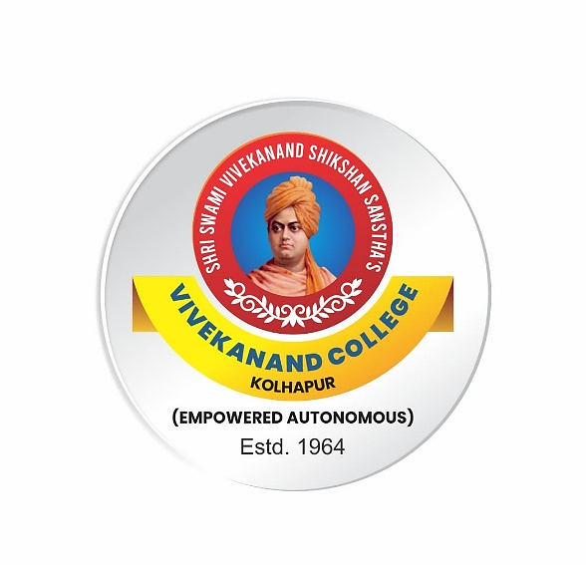

**Syllabus**

**for**

**B.C.S. Part I and B.C.A. Part I**

**AEC: Business Communication**

***Under NEP 2020***

**Syllabus with effect from June, 2024**

(Subject to modifications in the future)

**To be implemented from 2024-2025**

**B.C.S. Part I and B.C.A. Part I**

**AEC: Business Communication**

**Credits:2 Theory:40marks Internal:10Marks**

**Semester I Course Outcomes:**

# After completing this course the students will be able to:

**CO1**: Understand the concept, process and importance of communication.

**CO2**: Gain knowledge of media of communication.

**CO3**: Develop skills of effective communication –both written and oral.

**CO4**: Familiar with interdepartmental communication.

|  |  |  |  |
| --- | --- | --- | --- |
| **Module No** | **Title** | **Hours** | **Credits** |
| **Module I** | 1. **Introduction to Communication:**   Basic types of communication- Reading, Writing, Listening, Speaking, Purpose of Communication,  Process of Communication,  Importance of Communication in Business, Barriers to Communication,  Measures to Overcome the Barriers to Communication. | **15** | **1** |
| 1. **Verbal and Non-verbal Communication**   **Verbal**: Oral and written, its merits and demerits  **Non-verbal**: Kinesics, Oculesics, Haptics, Proxemics, Chronemics, Physical Appearance, Para Language, its merits and demerits |
| **Module II** | **English for Banking and Industries**   1. **Writing Memos, Circulars:**   Memo-Characteristics of a memo, Language and writing style of a memo- Format of a Memo;  Circulars-Guidelines for writing a circular-Languages and writing style of a circular- Format of a circular;   1. **Writing Notice, Agenda and Minutes:**   Purpose-Format-Important points to remember  while writing a notice, Agenda and Minutes | **15** | **1** |

**Semester II**

**Course Outcomes:**

# After completing this course the students will be able to:

**CO1**: Understand the concept, process and importance of communication network.

**CO2**: Gain knowledge of interdepartmental communication network.

**CO3**: Develop skills of effective communication-both oral and written.

**CO4**: Familiar with business correspondence.

|  |  |  |  |
| --- | --- | --- | --- |
| **Module No** | **Title** | **Hours** | **Credits** |
| **Module III** | 1. **Communication Network:**   Scope and Types of Communication Network, Formal and Informal Communication Network, Upward Communication,  Downward Communication, Horizontal Communication,  Diagonal Communication,  Grapevine. | **15** | **1** |
| 1. **Writing Business Letter:**   Importance of Business Letters,  Difference between Personal and Business Letters, Structure and Format of Business Letters,  Types of Business Letters-  Enquiry letter, complaint letter, request letter |
| **Module IV** | 1. **Oral Skills**   Oral and written skill, oral presentation: Comparing, Power Point Presentation, Interviewing famous Persons. | **15** | **1** |
| 1. **Report Writing**   Introduction: Format of Report, Specimen of Report, Elements of Report, Types of Report, Structure of Report, Parts of Report. |

**References:**

1. Chakraborty, Puri, and Dahiya. *English Communication*, Macmillan Publishers India Pvt. Ltd., 2017.
2. Ingole, Mamata. *Oasis*, Orient BlackSwan Pvt Ltd, 2022.
3. Nandvadekar, V.D. *English for Business Communication*, Shivaji University, 2019.
4. Rai, Urmila, and Rai, S.M. *Business Communication*, Himalaya Publishing House, 2008.
5. Rhoda, A. Doctor. *Business Communication*, Sheth Publishers Pvt. Ltd., 2009.
6. Singh, P.P. *Modern Business Communication*, Regal Publication, 2007.

Top of Form

Bottom of Form

**Evaluation**

|  |  |  |  |
| --- | --- | --- | --- |
| **Semester I & II** | **Theory/**  **Semester-end exam** | **Practical/Internal Evaluation** | **Credits** |
| 40 Marks | 10 Marks | 2 (For each semester) |

|  |  |
| --- | --- |
| **Internal Evaluation** | **Marks** |
| Home Assignment/Test/ Summary writing/book review/ student project | 10 |

**Pattern of Question Paper Sem I Total Marks: 40 Marks**

|  |  |  |  |  |
| --- | --- | --- | --- | --- |
| **Q. No.** | **Sub Q.** | **Types of Questions** | **Based on** | **Marks** |
| Q.1 | A | Multiple choice question with alternatives | All modules | 8 |
| Q.2 | A | Answer in 200-250 words | All modules | 16 |
| Q.3 | A | Draft memo or circular | Module II | 5 |
| Q.4 | A | Draft Notice & Agenda Or  Draft Minutes | Module II | 5 |
| Q.5 | A | Short Notes | All Modules | 6 |

**Pattern of Question Paper Sem II Total Marks: 40 Marks**

|  |  |  |  |  |
| --- | --- | --- | --- | --- |
| **Q. No.** | **Sub Q.** | **Types of Questions** | **Based on** | **Marks** |
| Q.1 | A | Multiple choice question with alternatives | All modules | 8 |
| Q.2 | A | Answer in 200-250 words | All modules | 16 |
| Q.3 | A | Write a Complaint letter or Inquiry letter or Request letter | Module III | 5 |
| Q.4 | A | Draft a formal report or informal report | Module IV | 5 |
| Q.5 | A | Short Notes | All Modules | 6 |