“**“Dissemination of Education for Knowledge, Science and Culture”**

* **Shikshanmaharshi Dr. Bapuji Salunkhe**

**Shri Swami Vivekanand Shikshan Sanstha’s**

**Vivekanand College, Kolhapur**

**(Empowered Autonomous)**

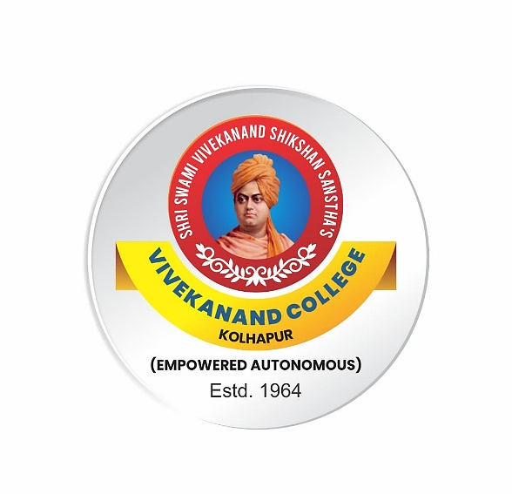

**Syllabus**

**for**

**Bachelor of Arts**

***B.A. Part-II***

***(Semester III, IV)***

**Ability Enhancement Course (AEC): English for Communication**

***NEP2020***

**Syllabus with effect from June, 2024**

(Subject to modifications in the future)

**BA II English (Semester III)**

**Ability Enhancement Course (AEC): English for Communication**

**Course Outcomes:**

**On completion of the course, students will be able to:**

**CO1**: Develop communication skills in English, both oral and written.

**CO2**: Acquire Presentation Skills and Compering Skills.

**CO3**: Develop English language skills for improving employability.

**CO4**: Inculcate human values through poems and prose.

|  |  |  |  |
| --- | --- | --- | --- |
| **Modules** | **Syllabus** | **Teaching**  **Hours** | **No. of Credits** |
| **Module I** | **Oral Skills**  **A) Oral and Written English**  I. PPT Presentation Skills  II. Compering  III. Interviewing Skills  IV. Interviewing Famous Personalities  **B) ‘A Real Good Smile’ by Bill Naughton (Short story)**  **C) ‘Mending Wall’ by Robert Frost (Poem)** | 15 | 1 |
| **Module II** | **Conversational Skills**   1. **Formal and Informal conversation**   Expressing Agreement, Disagreement and Partial Agreement and Disagreement, Stating an opinion, Complaint, Interpreting and Leaving a Conversation   1. **‘Preparation for England’ by M. K. Gandhi** 2. **‘Father Returning Home’ by Dilip Chitre (Poem)** | 15 | 1 |

**BA II English (Semester IV)**

**Ability Enhancement Course (AEC): English for Communication**

**Course Outcomes:**

**On completion of the course, students will be able to:**

**CO1**: Study E-Communication and use it in day-to-day life.

**CO2**: Understand process of writing, posting, linking and sharing content on blog.

**CO3**: Develop professional attitude conceptual knowledge and skills required for Bank and Industries.

**CO4**: Cultivate a broad, human and cultured outlook.

|  |  |  |  |
| --- | --- | --- | --- |
| **Modules** | **Syllabus** | **Teaching**  **Hours** | **No. of Credits** |
| Module III | 1. **E- Communication** 2. Email Writing 3. Blog Writing 4. The Selfish Giant - Oscar Wilde 5. Auto Wreck - Karl Shapiro | 15 | 1 |
| Module VI | 1. **English for Banking and Industries** 2. Notice ,Agenda and Minutes 3. Writing Advertisements 4. **‘An Old Man’s Ageless Wisdom’ by Sudha Murty** 5. **‘My Soul has a Hat’ by Mario de Andrade (Poem)** | 15 | 1 |

**References**:

1. Lester, Mark. Handbook of English Grammar and Usage. 3rd ed., Tata McGraw-Hill, New Delhi.
2. Mohan, Krishna, and Meera Banerji. Developing Communication Skills. Macmillan, 2007.
3. Seely, John. Oxford Guide to Effective Writing and Speaking. Oxford UP, 2005.

**Division of Teaching (Semester III and IV): 4 Modules X 15 Periods= 60 Periods**

**Evaluation**

|  |  |  |  |  |
| --- | --- | --- | --- | --- |
| **Semester III and IV** | **Theory/**  **semester-end exam** | **Practical/Internal Evaluation** | **Total Marks** | **Credits** |
| AEC | 15marks | 10marks | 25 Marks (for each semester) | 4 (2 for each Semester) |

**Continuous Internal Evaluation (CIE)**

|  |  |
| --- | --- |
| **Internal Evaluation** | **Marks** |
| Home Assignment/Test/ Summary writing/book review/ Seminar /Project | 10 |

**Pattern of Question Paper (Total Marks -15)**

**Semester III**

|  |  |  |  |
| --- | --- | --- | --- |
| **Q. No** | **Type of Question** | **Based on** | **Marks** |
| Q.1 | Three **Multiple choice questions** with four alternatives. | Prose and  Poetry | 03 |
| Q2 | Answer the following **questions in** **3-4 sentences** each (2 out of 4) | 2 on Prose and 2 on Poetry | 04 |
| Q.3 | Question to be set on Oral Skills | Module I A | 04 |
| Q.4 | Question to be set on Conversational Skills | Module II A | 04 |

**Pattern of Question Paper (Total Marks 15)**

**Semester IV**

|  |  |  |  |  |
| --- | --- | --- | --- | --- |
| **Q. No** | **Sub. Q.** | **Type of Question** | **Based on** | **Marks** |
| Q.1 | A. | Three **Multiple choice questions** with four alternatives. | Prose and  Poetry | 03 |
| Q2 | A | Answer the following **questions in** **3-4 sentences** each (2 out of 4) | 2 on Prose and 2 on Poetry | 04 |
| Q.3 | A | Question to be set on **E- Communication** | Module III | 04 |
| Q.4 | A | Question to be set on **English for Banking and Industries** | Module VI | 04 |