**“Dissemination of Education for Knowledge, Science and Culture”**

**-Shikshanmaharshi Dr. Bapuji Salunkhe**

**Shri Swami Vivekanand Shikshan Sanstha’s**

**Vivekanand College, Kolhapur**

**(Empowered Autonomous)**

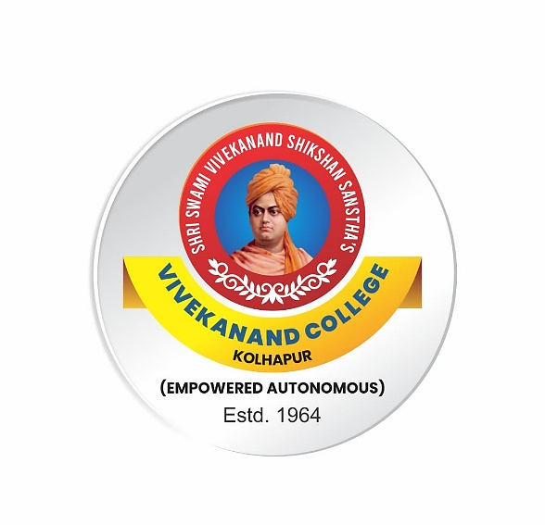

**Syllabus**

**for**

**Bachelor of Commerce**

***B.Com. Part-II* English**

***(Semester III, IV)***

***Ability Enhancement Course (AEC)***

***English for Business Communication***

***NEP2020***

**Syllabus with effect from June, 2024**

(Subjecttomodifications in the future)

**B. Com II (Semester III)**

**AEC: English for Business Communication**

**Course Outcomes: On completion of the course, students will be able to:**

CO1: Develop communication skills in English, both oral and written.

CO2: Acquired the skills such as PPT Presentation Skills and Compering Skills.

CO3: Developing writing skills for employability.

CO4: Inculcate human values through poems and prose.

|  |  |  |  |
| --- | --- | --- | --- |
| **Modules** | **Syllabus** | **Teaching**  **Hours** | **No. of Credits** |
| Module I | OralSkills  A) I .Oral and Written English  II. PPT Presentation Skills  III Compering  IV Interviewing Famous Personalities  V Interviewing Skills  *B)* A Stormy Arrival in South Africa- M.K.Gandhi  C)The Road Not Taken- Robert Frost(Poem*)* | 15 | 1 |
| Module II | Conversational Skills  A)Formal and Informal conversation  Expressing Agreement ,Disagreement and Partial Agreement and Disagreement ,Stating an opinion ,Complaint ,Interpreting and Leaving a Conversation   1. The Childless One- Jai Nimkar(Short Story) 2. Breathing Spaces- Rana Nayar(Poem) | 15 | 1 |

**B. Com II (Semester IV)**

**AEC: English for Business Communication**

**Course Outcomes: On completion of the course, students will be able to:**

CO1: Study E-Communication and their uses in day today life.

CO2: Understand process of writing, posting, linking and sharing content on blog.

CO3: Develop professional attitude conceptual knowledge and skills required for Bank and Industries.

CO4: Cultivate a broad, human and cultured outlook.

|  |  |  |  |
| --- | --- | --- | --- |
| **Modules** | **Syllabus** | **Teaching**  **Hours** | **No. of Credits** |
| Module III | A)E- Communication   1. Email Writing 2. Blog Writing and E-Vlog   B) Senor Payroll –William E. Barrett ( Short Story)  C) I Am The People, The Mob- Carl Sandburg (Poem) | 15 | 1 |
| Module VI | A) English for Banking and Industries   1. Notice, Agenda and Minutes 2. Writing Advertisements   B) My Financial Career – Stephen Leacock (Short Story)  C) Phenomenal Woman - Maya Angelou (Poem) | 15 | 1 |

**References**:

John Seely (2005) Oxford Guide to Effective Writing and Speaking

Krishna Mohan and Meera Banerji (2007) Developing Communication Skills, Macmillan

Lester Mark,Tata MC Grew, Handbook of English Grammar and Usage, Hill PublishingCompany-

New Delhi.

Nandavadekar V.D.(2019)Ability Enhancement Compulsory Course (CBCS) ,B.ComII English For Communication ( Compulsory English), Shivaji University Press – Kolhapur .ISBN

Ingole, Mamta Oasis A textbook for College Students.

* **Division of Teaching:4ModulesX15Periods=60PeriodsEvaluation**

**AEC- CBCS English for communication (Compulsory English)**

|  |  |  |
| --- | --- | --- |
| **Semester I** | **Theory/ semester-end exam** | **Practical/InternalEvaluation** |
| AEC | 40 Marks | 10 Marks |

**Continuous Internal Evaluation (CIE)**

|  |  |
| --- | --- |
| **Evaluation Type** | **Marks** |
| Home Assignment/Test/ Summary writing/book review/ Seminar /Project | 10 |

**Pattern of Question Paper Total Marks-40**

|  |  |  |  |  |
| --- | --- | --- | --- | --- |
| Q. No | Sub.Q. | TypeofQuestion | Basedon | Marks |
| Q.1 | A. | **Multiple choice questions** with four alternatives. | Prose and Poetry | 04 |
|  | B | Vocabulary exercises. | Prose and Poetry | 02 |
| Q2 | A | Answer the following **questions in3-4 sentences** each. (3 out of 5) | Prose and Poetry | 06 |
|  | B | Write a short note on the following in **7-8 sentences.**  (2 out of 4) | Prose and Poetry | 08 |
| Q.3 | A | Questions to be set on PowerPoint Presentation (1 out of 2) | Module 1 | 05 |
| Q.4 | A | Questions to be set on compering script or interviewing the person. | Module 1 | 07 |
| Q.5 | A | Questions to be set on Conversational Skills  Skills (2 out of 3) | Module 2 | 08 |

**B. Com II (Sem IV) AEC- English for Business Communication**

**Continuous Internal Evaluation (CIE)**

|  |  |
| --- | --- |
| **Evaluation Type** | **Marks** |
| Home Assignment/Test/ Summary writing/book review/ Seminar /Project | 10 |

**Pattern of Question Paper Total Marks-40**

|  |  |  |  |  |
| --- | --- | --- | --- | --- |
| Q. No | Sub.Q. | Type of Question | Based on | Marks |
| Q.1 | A. | **Multiple choice questions** with four alternatives. | Prose and Poetry | 04 |
|  | B | Vocabulary exercises. | Prose and Poetry | 02 |
| Q2 | A | Answer the following **questions in3-4 sentences** each. (3 out of 5) | Prose and Poetry | 06 |
|  | B | Write a short note on the following in **7-8 sentences.**  (2 out of 4) | Prose and Poetry | 08 |
| Q.3 | A | Questions to be set on E-Communication  (2 out of 4) | Module 1 | 08 |
| Q.4 | A | Questions to be set on Notice, Agenda or Minutes | Module 2 | 07 |
| Q.5 | A | Questions to be set on Writing Advertisements | Module 2 | 05 |