**“Dissemination of Education for Knowledge, Science and Culture”**

* **Shikshanmaharshi Dr. Bapuji Salunkhe**

**Shri Swami Vivekanand Shikshan Sanstha’s**

**Vivekanand College, Kolhapur**

**(Empowered Autonomous)**

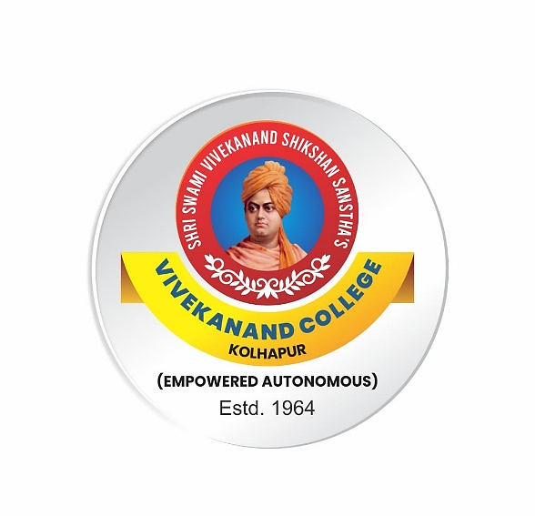

**Syllabus**

**for**

**B.Com. Part I**

**AEC: English for Business Communication (2AEC02ENG11)**

***Under 2.0 NEP 2020***

**Syllabus with effect from June, 2024**

(Subject to modifications in the future)

**To be implemented from 2024-2025**

“Dissemination of Education for Knowledge, Science and Culture”

* Shikshanmaharshi Dr. Bapuji Salunkhe

**Shri Swami Vivekanand Shikshan Sanstha’s**

**Vivekanand College, Kolhapur (Empowered Autonomous)**

**Department of English**

**B.Com. Part I (CBCS)**

**AEC: English for Business Communication (2AEC02ENG11)**

**Credits: 2 Theory: 40 marks Internal: 10 marks**

**Semester I**

**Course Outcomes:**

**After completion of the course students will be able to:**

**CO1**: Write grammatically correct English.

**CO2**: Use various expressions in general communicative contexts.

**CO3**: Increase interest in and appreciate of English texts.

**CO4**: Interpret texts with sensitivity to both textual and contextual cues.

|  |  |  |  |  |
| --- | --- | --- | --- | --- |
| **Module** | **Skills** | **Sub-points** | **Teaching**  **Hours** | **Credits** |
| Module I | 1. Description | * Describing persons, places, objects, * Describing duties-- of receptionist, bank manager sales-person and cashier * Describing procedure –of opening an account, taking an admission. | 15 | 1 |
|  | 1. Grammar | * Parts of Speech   Types of Sentences: Simple, Compound and Complex |
|  | C. Poem | * ‘Money Madness’ by D. H. Lawrence * Success is counted Sweetest by Emily Dickinson |
| Module II | A. Narration | * Narration – Present events * Narrating past event / experience * Narration from Different points of View (First person and Third person) --Story / News Report | 15 | 1 |
|  | B. Grammar | * Tenses   Link-words / Connectors |
|  | C. Prose | * Why a Start-up Needs to Find its Customers First by Pranav Jain * Dhirubhai Ambani |

**B.Com. Part I (CBCS)**

**AEC: English for Business Communication (2AEC02ENG21)**

**Semester II**

**Course Outcomes:**

After completion of the course the students will be able to:

**CO1**: Produce grammatically correct English.

**CO2**: Use various expressions in Business communication.

**CO3**: Increase interest in and appreciation of English texts.

**CO4**: Interpret texts with due sensitivity to both textual and contextual cues.

|  |  |  |  |  |
| --- | --- | --- | --- | --- |
| **Module** | **Skills** | **Sub-points** | **Teaching**  **hours** | **Credits** |
| Module III | A. Writing Official Letters | * Letter of Enquiry, Reply to the Letter of Enquiry * Placing an Order,   Letter of Complaint, Reply to the Complaint. | 15 | 1 |
|  | B. Grammar | * Types of Sentences |
|  | C. Prose | * “Commerce Education: Key to Prosperity and Security”   by Manjushree Deshpande   * Rahul Bajaj |
| Module IV | A. Interdepartmental Communication | * Memorandum * Office order and Circular | 15 | 1 |
|  | B. Grammar | Elements of Clause |
|  | C. Poem | * “Where the mind is without Fear’ Rabindranath Tagore * “Trees” by Joyce Kilmer |

|  |  |  |  |  |  |
| --- | --- | --- | --- | --- | --- |
| **Paper**  **Number** | **Title of the paper** | **Course Code** | **Semester End Examination** | **Continuous Internal Evaluation Marks** | **Total Marks** |
| I | **AEC: English for Business Communication** | **2AEC02ENG11** | 40 | 10 | 50 |
| II | **AEC: English for Business Communication** | **2AEC02ENG21** | 40 | 10 | 50 |

**B. Com Part I (Sem I)**

**AEC: English for Business Communication**

**Course Code :2AEC02ENG11**

**Continuous Internal Evaluation (CIE)**

|  |  |
| --- | --- |
| **Evaluation Type** | **Marks** |
| **Home Assignment/ Open Book Test/ Tutorial/ Unit Test** /book review/ student project | 10 |

**Pattern of Question paper**

|  |  |  |  |  |
| --- | --- | --- | --- | --- |
| **Que. No** | **Sub. Q.** | **Types of Question** | **Based on** | **Marks** |
| Q.1 | A | Four **multiple choice questions** with four  alternatives. | Module I & II  (Prose & Poem) | 04 |
| Q.2 | A | Do as directed | Module I & II  (Grammar) | 06 |
| Q.3 | A | Answer in 2 to 3 sentences (any 3 of 5) | Module I & II  (Prose & Poem) | 06 |
|  | B | Write Short Notes (2 out of 4) | Module I & II  (Prose & Poem) | 08 |
| Q.4 | A | Question to be set on Description (2 of 4) | Module I | 08 |
| Q.5 | A | Question to be set on Narration (2 of 4) | Module II | 08 |

**B. Com Part I (Sem II)**

**AEC: English for Business Communication**

**Course Code: 2AEC02ENG21**

**Continuous Internal Evaluation**

|  |  |
| --- | --- |
| **Evaluation Type** | **Marks** |
| **Home Assignment/ Open Book Test/ Tutorial/ Unit Test** /book review/ student project | 10 |

**Pattern of Question Paper**

**Marks: 40 Time: 2 hrs**

|  |  |  |  |  |
| --- | --- | --- | --- | --- |
| **Que. No** | **Sub. Q.** | **Types of Question** | **Based on** | **Marks** |
| Q.1 | A | Four **multiple choice questions** with four  alternatives. | Module III, IV  (Prose & Poem) | 04 |
| Q.2 | A | Do as directed | Module III, IV  (Grammar) | 06 |
| Q.3 | A | Answer in 2 to 3 sentences (any 3 of 5) | Module III, IV  (Prose & Poem) | 06 |
|  | B | Write Short Notes (2 out of 4) | Module III, IV  (Prose & Poem) | 08 |
| Q.4 |  | Official Letter writing (2 questions to be set) | Module III | 8 |
| Q.5 |  | Write notice, memo or circular ( 2 questions to be set) | Module IV | 8 |

**References :**

* Board of Editors , Oasis, Orient Blackswan 2022
* Board of Editors, Pathmaker, Orient Blackswan 2021
* Murphy, Raymond. Essential English Grammar. Cambridge University Press, 2000.
* Sood , S.C.  *Developing Language Skills I:Oral Communication and Reading Comprehension, Writing Skills, and Workbook,* [Manohar](https://www.google.co.in/search?hl=en&q=inpublisher:%22Manohar%22&tbm=bks&sa=X&ved=2ahUKEwjKtIaut8vwAhXzjuYKHQ9BCiEQmxMoADAIegQIEhAC), 2003.
* Walker , [Bonnie L.](https://www.google.co.in/search?hl=en&q=inauthor:%22Bonnie+L.+Walker%22&tbm=bks)  AGS Grammar and Composition Skills, American Guidance Service, 1997
* Gupta, S. C. Practical English Grammar, Arihant, 2012.